**SMPTE AG-04-ST:2020**

Administrative Guideline

Standards Template (for Drafts)

# Foreword

Warning

*This document is an unpublished, confidential work under development and shall not be referred to as a SMPTE Standard, Recommended Practice, or Engineering Guideline. It is distributed for review and comment; distribution does not constitute publication. Recipients of this document are strongly encouraged to submit, with their comments, notification of any relevant patent rights of which they are aware and to provide supporting documentation.*

# Introduction

Your introduction text goes here.

At the time of publication, no notice had been received by SMPTE claiming patent rights essential to the implementation of this Engineering Document. However, attention is drawn to the possibility that some of the elements of this document may be the subject of patent rights. SMPTE shall not be held responsible for identifying any or all such patent rights.

# 1 Scope

Your Scope Text

# 2 Normative References

Your Normative References

# 3 Terms and Definitions

Your Terms and Definitions

# 4 Technical Content

These clauses include the technical content of the Engineering Document.

# 5 Headings and Lists

## 5.1 Heading 2

## 5.2 Heading 3

In this section, lists and headings are shown:

* An auto bullet list
  + With a nest
    1. And another nest
    2. And one more
  + Using numbered lists
    1. Here is a numbered list
    2. With 3 entries
    3. And a sub-level
    4. With 2 entries
    5. And a last entry

### 5.2.1 Another Heading 3

#### 5.2.1.1 This is heading 4

##### 5.2.1.1.1 And heading 5

###### 5.2.1.1.1.1 And heading 6

# 6 Style Recommendations

## 6.1 Notes

NOTE: This is purely informational

## 6.2 Examples

EXAMPLE: 5 oranges

## 6.3 Equations

The tone mapping offset, gain and gamma values shall be applied according to the equation:

|  |  |
| --- | --- |
| $y=(min(max(0,(x×g)+o),1))^{P}$ | ( 1 ) |

where y is the output value x is the input value g is the value of Tone Mapping Gain o is the value of Tone Mapping Offset p is the value of Tone Mapping Gamma

## 6.4 Figures

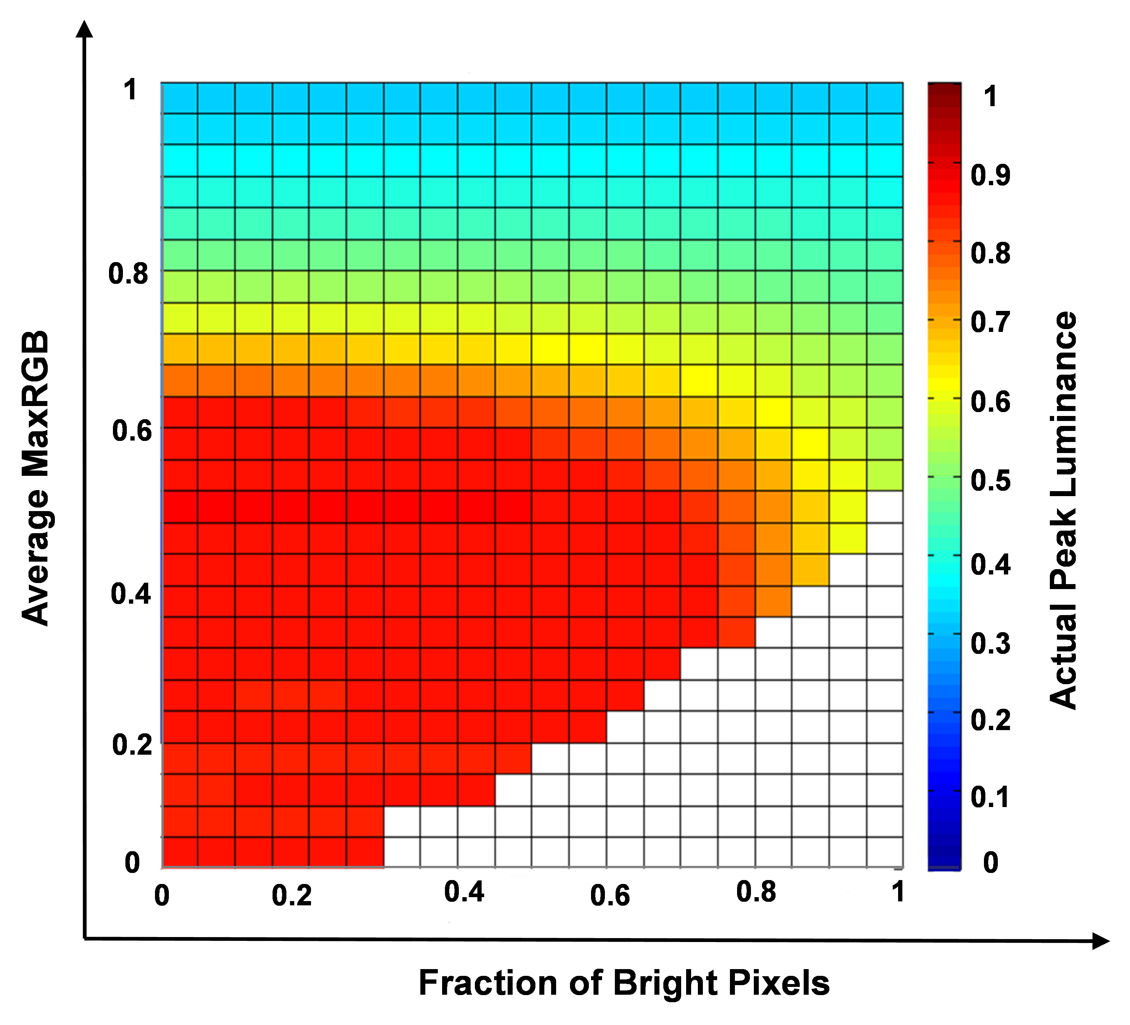

Two-dimensional LUT of actual peak luminance

## 6.5 Tables

Example Metadata sets with Time Intervals

|  |  |  |
| --- | --- | --- |
| Example set | TimeIntervalStart | TimeIntervalDuration |
| Application Set A | 0 | 2 |
| Application Set B | 0 | 3 |
| Application Set C | 5 | 2 |

# Annex A All Annexes are Numbered

## Annex A.1 Even the sub headings are numbered

By default syntax highlighting is used in code, XML and JSON.

<xs:schema attributeFormDefault="unqualified" elementFormDefault="qualified"  
 xmlns:xs="http://www.w3.org/2001/XMLSchema">  
 <!-- for restricting the termNote Attributes-->  
 <xs:simpleType name="LMTtermNoteLabelType">  
 <xs:restriction base="xs:string">  
 <xs:enumeration value="Language Group Name" />  
 <xs:enumeration value="Language Group Tag" />  
 <xs:enumeration value="Language Group Code" />  
 <xs:enumeration value="Audio Language Tag" />  
 <xs:enumeration value="Long Description 1" />  
 <xs:enumeration value="Long Description 2" />  
 <xs:enumeration value="Audio Language Display Name 1" />  
 <xs:enumeration value="Audio Language Display Name 2" />  
 <xs:enumeration value="Visual Language Tag 1" />  
 <xs:enumeration value="Visual Language Tag 2" />  
 <xs:enumeration value="Visual Language Display Name 1" />  
 <xs:enumeration value="Visual Language Display Name 2" />  
 <xs:enumeration value="Code" />  
 <xs:enumeration value="Notes" />  
 </xs:restriction>  
 </xs:simpleType>  
 <xs:simpleType name="relationTypeType">  
 <xs:restriction base="xs:string">  
 <xs:enumeration value="EQT" />  
 <!-- Equivalent To -->  
 <xs:enumeration value="BT" />  
 <!-- Broad Type -->  
 <xs:enumeration value="NT" />  
 <!-- Narrow Type -->  
 <xs:enumeration value="TT" />  
 <!-- Top Type -->  
 </xs:restriction>  
 </xs:simpleType>  
</xs:schema>

# Bibliography

A bibliography has no number